SoC-Based Out-of-Band Encryption Module with Key Management System
A Final Year / CE515 Project Report
Ehtesham Ali Khan
Uzair Ashfaq
Zohaib Ali Arif
This report presents a complete System-on-Chip (SoC) based hardware security solution implementing AES-256 encryption with an OS-independent Key Management System (KMS). The system is implemented on Zynq Zybo Z7-10 using PS–PL co-design methodology.

Abstract
Security of digital data has become a major concern in modern communication systems. Software-based encryption mechanisms rely heavily on operating systems, which may contain vulnerabilities. This project proposes a SoC-based out-of-band encryption module using AES-256 implemented in FPGA hardware. A dedicated Key Management System (KMS) is implemented in the Processing System (PS), while encryption and decryption are accelerated in Programmable Logic (PL). The design is validated through simulation, timing analysis, and functional verification.

1. Introduction
With the exponential growth of connected devices, secure data transmission has become critical. Traditional cryptographic solutions implemented in software are vulnerable to malware, OS backdoors, and side-channel attacks. Hardware-based cryptography using SoC platforms provides a more secure alternative by isolating sensitive operations.

2. Motivation and Problem Statement
Modern operating systems are complex and may expose cryptographic keys through software vulnerabilities. The motivation of this project is to eliminate dependency on the host OS by implementing encryption and key handling directly in hardware.

3. Project Objectives
- Design a secure SoC-based encryption architecture
- Implement AES-256 encryption/decryption in FPGA hardware
- Develop an OS-independent Key Management System
- Validate functionality using real hardware and simulation

4. SoC System Architecture
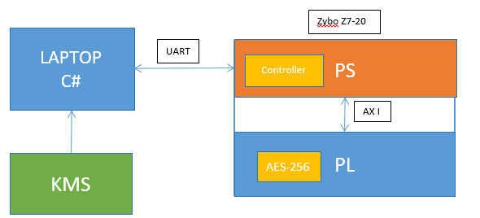
Figure 1: Proposed SoC out-of-band architecture (C# PC ↔ UART ↔ PS/PL with KMS and AES-256).

The proposed system follows a PS–PL co-design approach. The Processing System (ARM Cortex-A9) handles control, communication, and key management, while the Programmable Logic implements the AES-256 cryptographic accelerator.
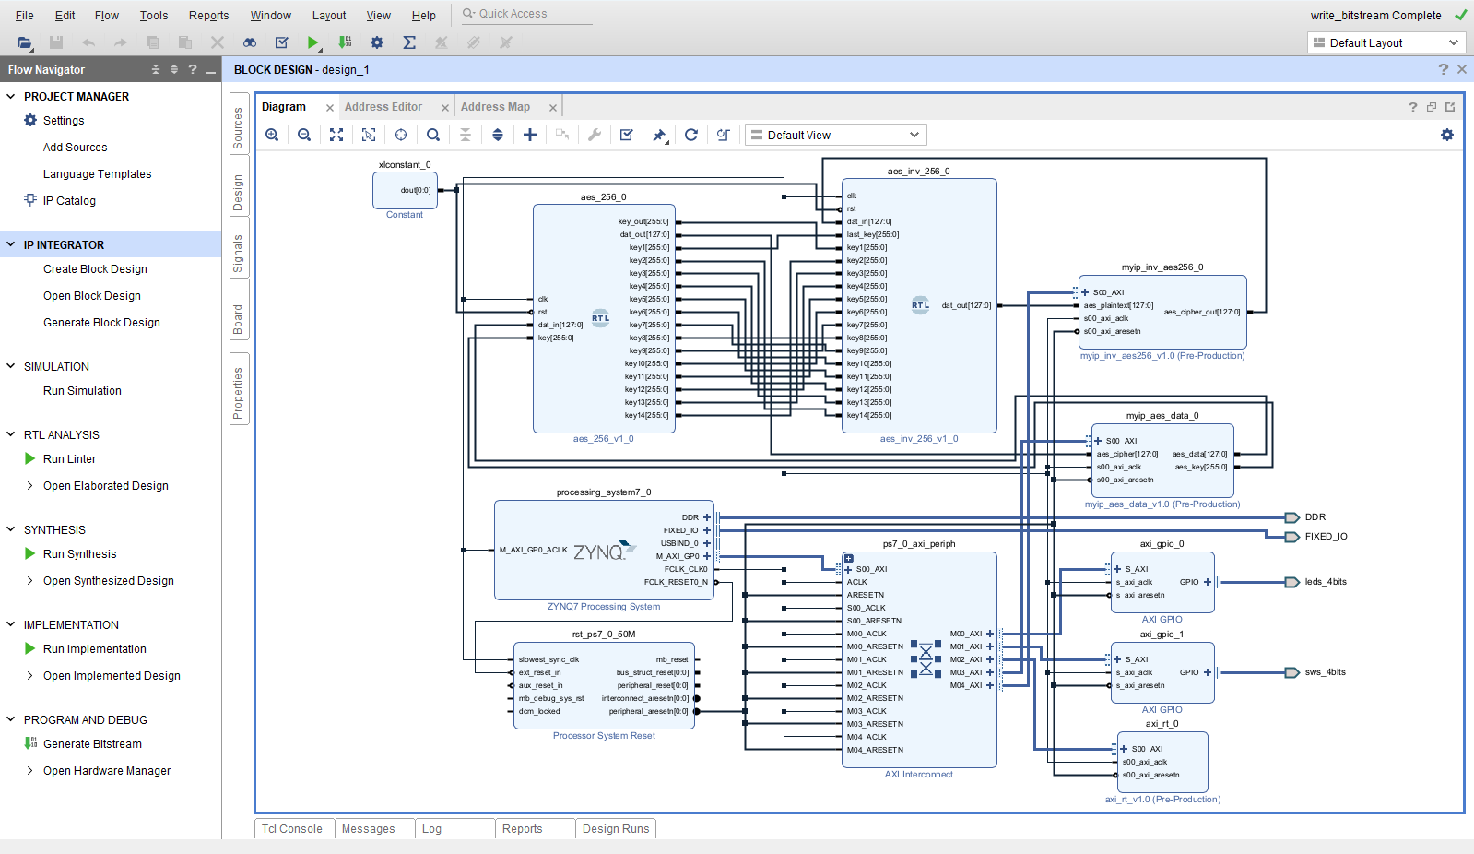

5. Hardware Platform: Zynq Zybo Z7-10
The Zynq Zybo Z7-10 board integrates a dual-core ARM processor with FPGA fabric on a single chip. AXI interconnects provide high-speed communication between PS and PL, making it ideal for secure SoC designs.

6. AES-256 Algorithm Overview
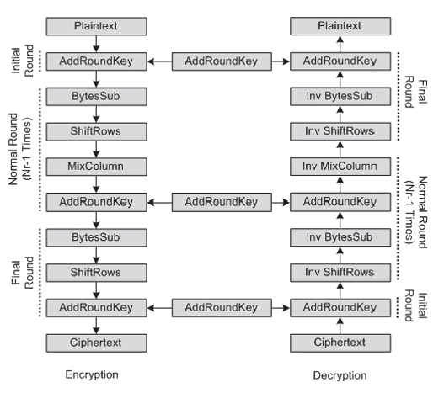
Figure 2: AES encryption and decryption round structure (high-level flow).

AES-256 is a symmetric block cipher standardized by NIST. It operates on 128-bit data blocks using a 256-bit key and performs 14 rounds of encryption. Each round consists of SubBytes, ShiftRows, MixColumns, and AddRoundKey operations.

7. AES-256 Hardware Implementation in PL
The AES-256 core is implemented in Verilog HDL and synthesized using Vivado 2019.1. Round transformations and key expansion logic are implemented as modular RTL blocks.
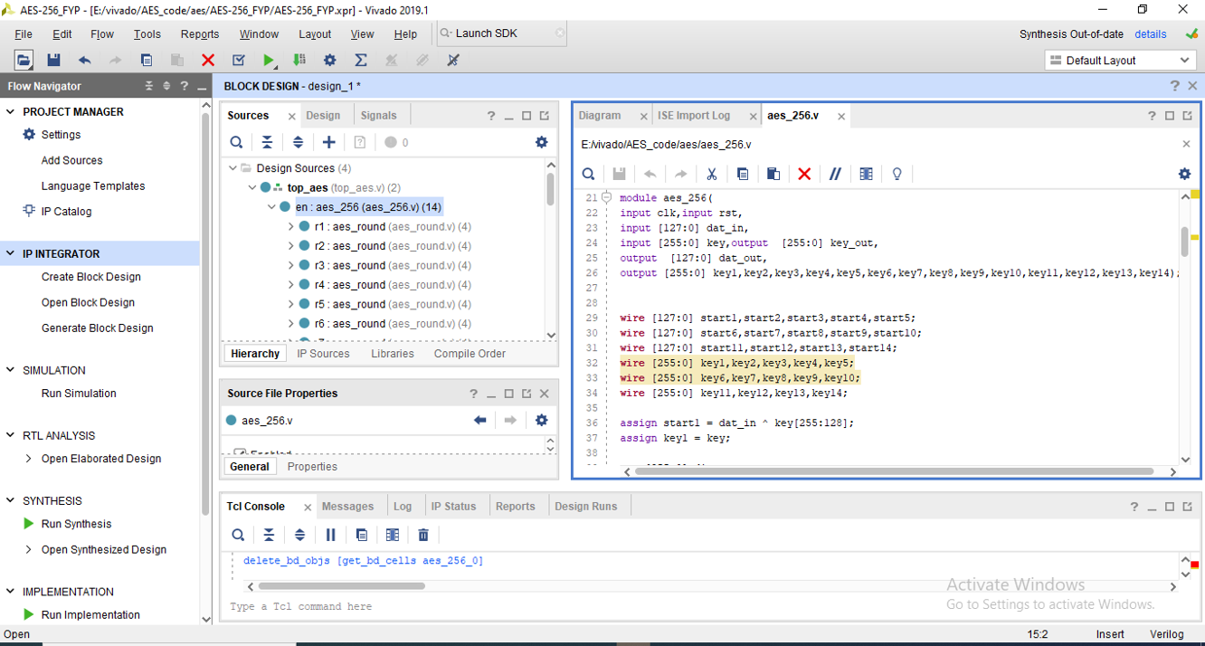

8. Key Management System (KMS)
The Key Management System is implemented in the Processing System. It securely stores and transfers cryptographic keys to the AES core using AXI interfaces. Keys are never exposed to the host operating system.

9. Out-of-Band Communication (UART)
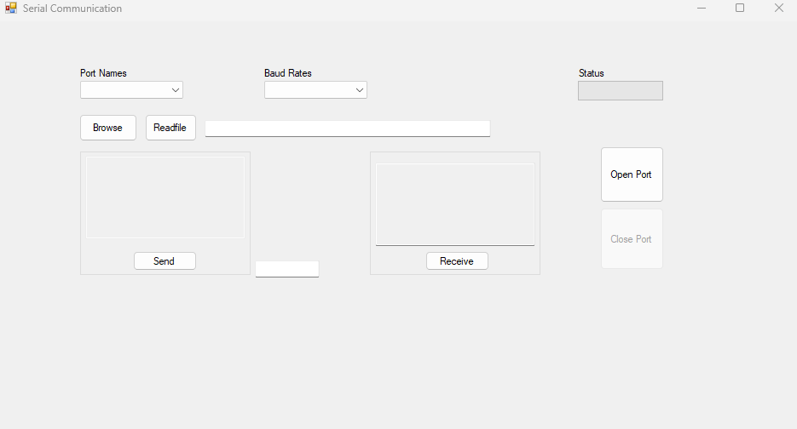
Figure 3: PC-side C# serial communication GUI used for UART data exchange.

UART is used as an out-of-band communication interface between the PC application and the SoC. Control commands and encrypted data are transmitted securely.

10. Functional Simulation and Verification
Functional verification is carried out using Vivado simulation tools. Known AES test vectors are used to verify correctness of encryption and decryption.
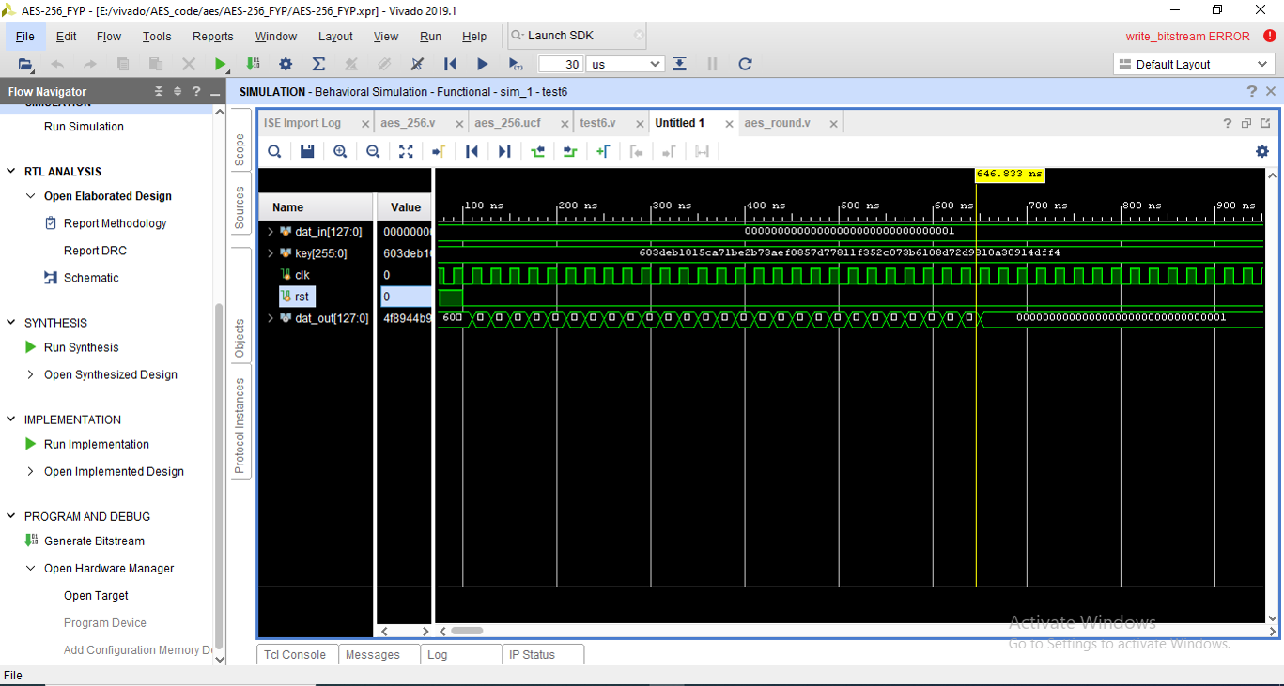

11. Synthesis and Timing Analysis
The design is synthesized and implemented using Vivado. Timing analysis confirms that all constraints are met with positive slack, ensuring reliable operation.
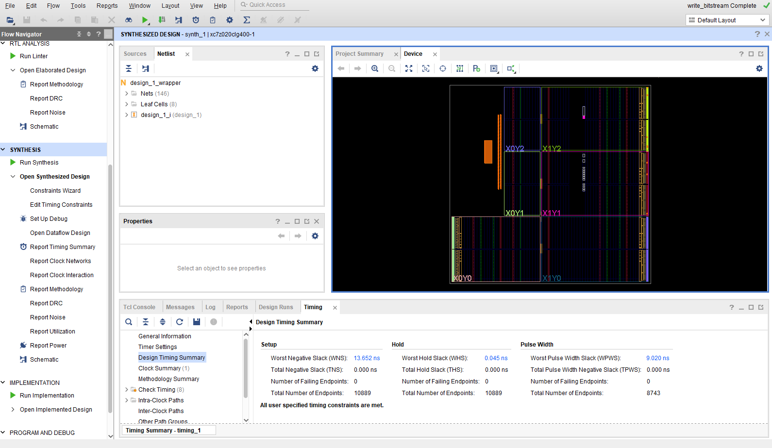

12. Results and Discussion
The implemented system successfully performs AES-256 encryption and decryption in hardware. Hardware acceleration significantly improves performance and security compared to software-only solutions.

13. Conclusion
This project demonstrates a complete SoC-based out-of-band encryption system with hardware-accelerated AES-256 and secure key management. The design validates the effectiveness of PS–PL co-design for hardware security applications.

14. Future Work
Future work includes integration of RSA/ECC for secure key exchange, secure boot support, and performance optimization through deeper pipelining.

10. Vitis (PS) Software Implementation
The Processing System (PS) software is developed using Xilinx Vitis Unified IDE. Its primary responsibility is to receive plaintext and cryptographic keys from the PC-side C# application via UART, configure the AES-256 hardware accelerator in the Programmable Logic (PL) through AXI-Lite registers, and return the encrypted or decrypted data back to the PC. This section describes the software architecture and data flow.

10.1 Role of PS Software
The Vitis application acts as a secure bridge between the external world and the FPGA logic. It performs UART communication, data formatting, register-level access to the AES core, and synchronization using control and status registers. All cryptographic computation is performed in hardware, ensuring OS-independent security.

10.2 Data Flow Between C#, PS, and PL
The PC application sends a 128-bit plaintext and a 256-bit AES key over UART. The PS receives this data, stores it in local buffers, and writes it to the AES IP registers in the PL using AXI-Lite. After triggering encryption or decryption, the PS polls the status register and reads back the 128-bit result, which is then transmitted back to the PC.
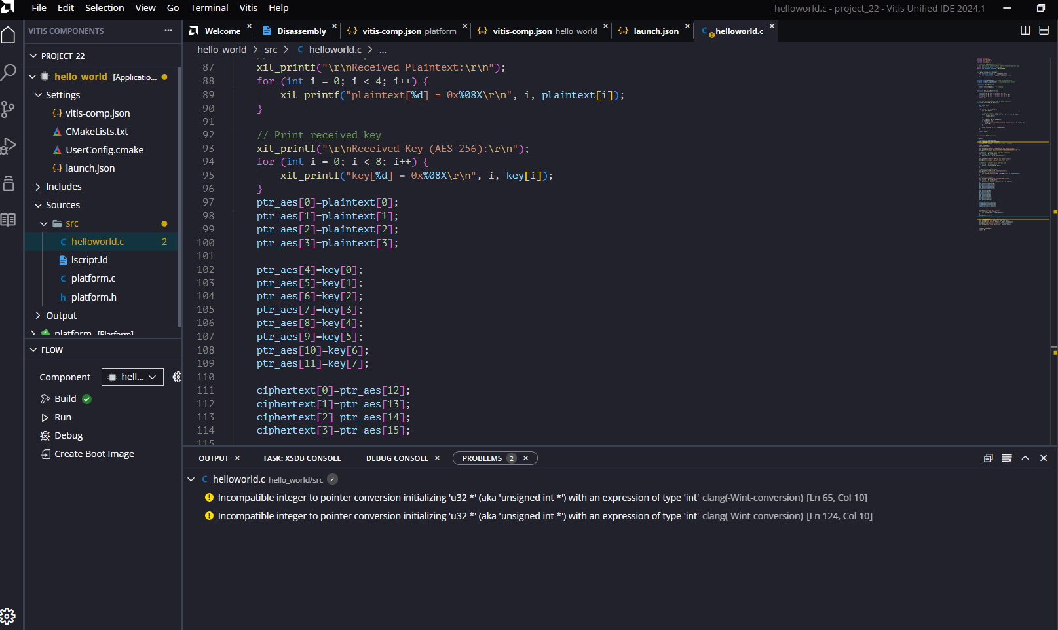
Figure: Vitis Unified IDE showing the PS application for UART communication and AXI access.

10.3 AXI-Lite Register Interface
The AES-256 hardware accelerator exposes a memory-mapped AXI-Lite interface. Plaintext is written as four 32-bit words, and the 256-bit key is written as eight 32-bit words. Control and status registers are used to start the operation and detect completion.
This software-hardware interaction completes the secure out-of-band encryption and decryption loop, demonstrating a full SoC-based cryptographic system.

